**CREATE A NEW SHELL SCRIPT**

**STEP 1:** Create a new Nano shell script using the command “nano”



**STEP 2:** Giving execute permission to the scripts1.sh file.



**Step 3:** Providing the contents to the file.

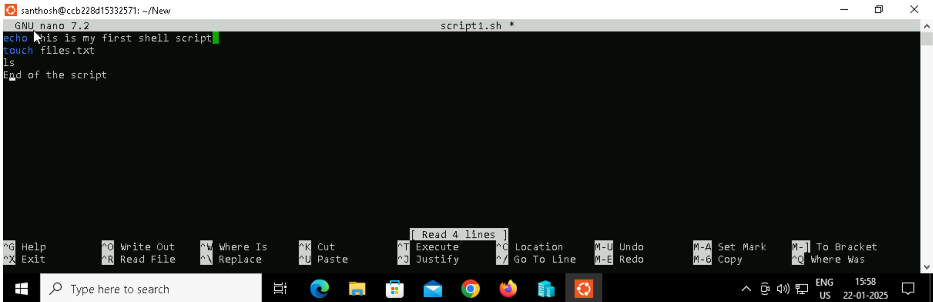

**Step 4:** Output

